# SWE20004 Technical Software Development – Assignment 1

Student Name: **Masrur Rahman Zahin**

Student ID: **101214608**

## Data Dictionary

|  |  |  |  |
| --- | --- | --- | --- |
| **Variable** | **Identifier** | **Type** | **Test Value** |
| Evolving fault | evolving_fault | Char | y |
| Permanent fault | permanent_fault | Char | y |
| Gradient | gradient | Double | 1 |
| Voltage | voltage | Double | -1 |
| Time interval | time_interval | Double | 150 |
| Repeat | repeat | Char | n |
| Run | run | Boolean | false |

## User Inputs

All the user inputs were taken before entering the decision tree because it keeps the codeblock more organized, clean, and easier to debug for any issues. The codeblocks are separated into “**Data Collection**” and “**Logic**”.

In the data collection codeblock, the user was asked to input all the values for the variable and within the codeblock, the data was validated. If the data entered by the user is valid then the data will be stored in the respective variable and moved on to the next, if not then the user will be asked to input the variable again until the proper value is provided. Any issue in this codeblock did not affect the flow or logic of the program as the values will never reach the logic codeblock without it being 100% valid. This also minimizes data error rate since the data input, validation and logic is not done in one go.

In the logic codeblock, it is just simple nested if loops, it reads the values entered by the user and pursues the logical flow. For example, if the value is true it follows the right path else it follows the left. The loops are very straight forward.

## Screenshots

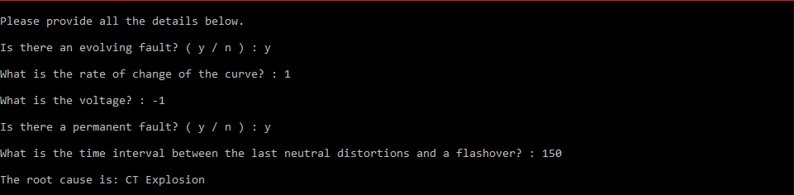

Figure 1: CT Explosion

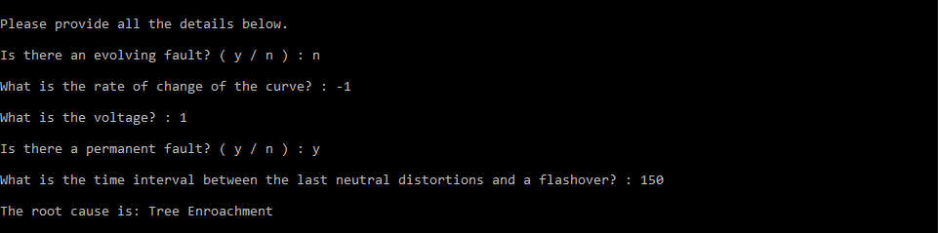

Figure 2: Tree Encroachment via Gradient

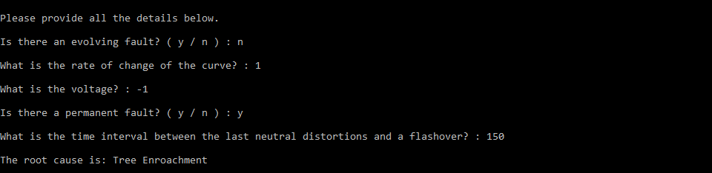

Figure 3: Tree Encroachment via Voltage

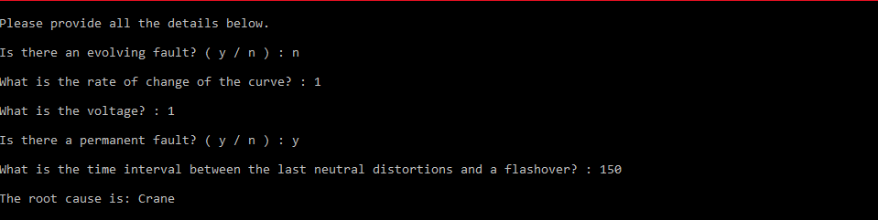

Figure 4: Crane

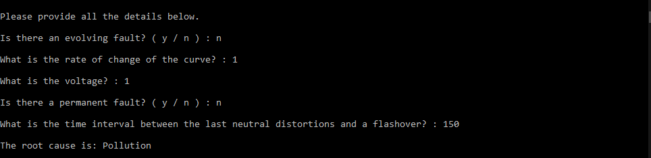

Figure 5: Pollution

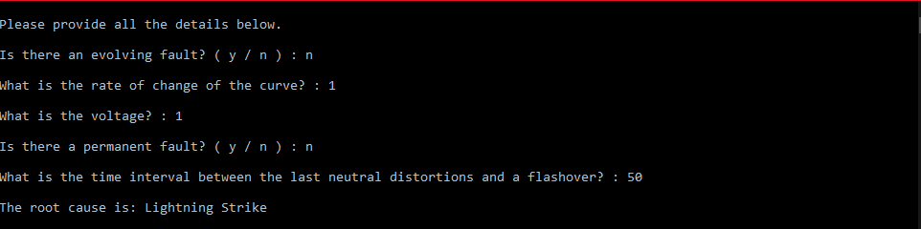

Figure 6: Lightning Strike

## Challenge Tasks

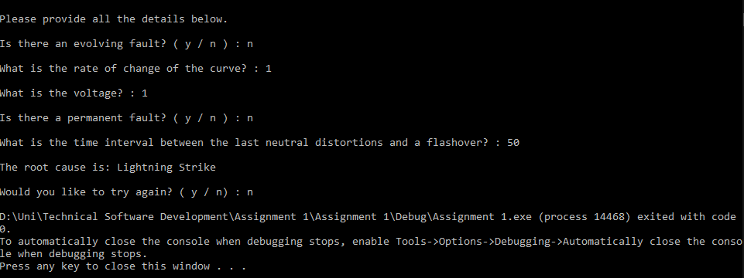

Figure 7: Task 1 – Repeat

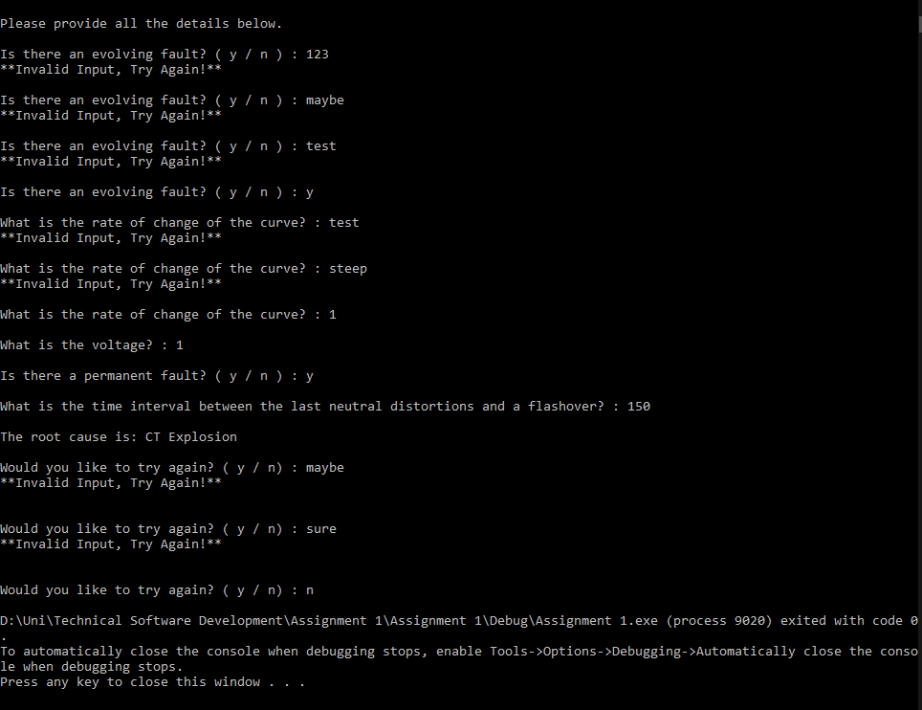

Figure 8: Task 2 - Validation